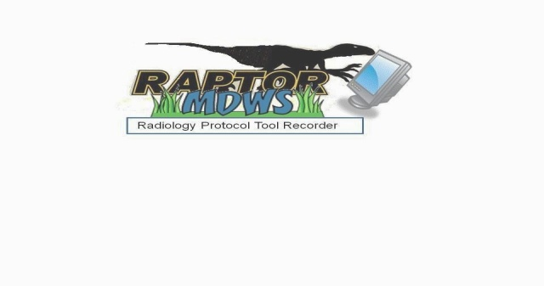

**RAPTOR User Acceptance Test Plan (UATP)**

Date: August 11, 2014

Draft Version: UAT release

**Revision History & Sign-off Sheet**

**Change Record**

|  |  |  |  |
| --- | --- | --- | --- |
| **Version** | **Date** | **Name** | **Revision Description** |
| .1 | 3/23/14 | SAN | Original Version Provided in advance of 3/23/14 release |
| .2 | 6/23/14 | SAN | Updated version provided in advance of 6/23/14 release |
| .3 | 6/30/2014 | VA, SAN | Updated at the 6/30/2014 Test Readiness Review |
| .4 | 7/7/2014 | SAN | Modification of Issue Tracking from Innovations to MantisBT |
| .5 | 7/14/2014 | SAN | Additional VistA accounts added |
| .6 | 8/11/2014 | SAN | Various Updates |

**Reviewers**

|  |  |  |  |
| --- | --- | --- | --- |
| **Name** | **Version Approved** | **Role** | **Date** |
| Innovations |  |  |  |
|  |  |  |  |
|  |  |  |  |
|  |  |  |  |
|  |  |  |  |

**Distribution**

|  |  |
| --- | --- |
| **Name** | **Date** |
| Innovations |  |
|  |  |
|  |  |
|  |  |
|  |  |

**Document Properties**

|  |  |
| --- | --- |
| **Item** | **Details** |
| Document Title |  |
| Author |  |
| Creation Date |  |
| Last Updated |  |

**Table of Contents**

1.0 Introduction

1.1 Project Overview

1.2 Scope

1.2.1 _ In Scope

1.2.2 Out of Scope

1.3 _ Objective

1.3.1 _ Primary Objective

1.3.2 Secondary Objective

2.0 UA Test Approach

2.1 Test Phases

3.0 UA Test Environment

3.1 UA Test Preparation

3.2 UA Test Data

4.0 Roles and Responsibilities

4.1 UAT Team

5.0 UAT Deliverables

5.1 UAT Activities

5.2 _ UAT Schedule

6.0 UA Test Cases

6.1 UA Test Cases

7.0 UAT Defects

7.1 UAT Defect Tracking

7.2 UAT Defect Prioritization

7.3 UAT Defect Lifecycle

8.0 Assumptions

# 1.0 Introduction

The purpose of this document is to outline the S.A.N. Business Consultants (SAN) User Acceptance Testing (UAT) process for the RAPTOR phase 2. This document will detail the UI test approach and what will be demonstrated for each increment. UAT is conducted to enable a user to validate that the software meets the agreed upon acceptance criteria.

SAN’s role in the UAT process is to oversee testing by assigning scripts to SMEs, providing general support, and serving as the primary UAT contact point throughout the test cycle. SAN will filter out any duplicate defects found and escalate high priority issues to the developers in a time sensitive manner.

## Project Overview

SAN shall enhance the current PoC RAPTOR Prototype by adding new functionalities as defined in the following table to improve the usability of the imaging exam ordering process. Through these enhancements, the imaging exam ordering process between the radiologist and the ordering provider shall allow the radiologist to access sufficient patient data (e.g., allergies, medications, provider notes, imaging reports, ionizing radiation exposure history) before assigning specific protocol instructions to direct how each examination must be performed by the ordering provider. These enhancements shall be collectively known as the Production RAPTOR Prototype. SAN shall provide pilot User Acceptance Test (UAT) support services to implement the Production RAPTOR Prototype. SAN shall procure, configure, prepare, deliver, and install the hardware that goes into the VA Region 1 Sacramento Data Center. SAN shall also install the Production RAPTOR Prototype applications at four additional VA Pilot production environments as identified in Sections 4.2 and 5.2.4 of this PWS. The VA Region 1 Sacramento Data Center, plus the four aforementioned VA Pilot production environments, that comprise the five VA pilot sites required by this PWS.

Additional functional enhancements will also be added to this document as they are added to the PWS.

## 1.2 Scope

### 1.2.1 In Scope

The following table (Table 1) shows the functional enhancements that were implemented in the March 23, 2014 Increment (shown in green highlight), those for implementation in the June 23, 2014 release (shown in yellow highlight) and those for implementation in the August 11, 2014 release (no highlight).

**Table 1 - Scope**

|  |  |  |  |
| --- | --- | --- | --- |
| **Item No.** | **Functional Enhancements for Production RAPTOR Prototype** | **Test Readiness** | **Out of Scope for this Release** |
| 1.1 | Contra-indications shall be clickable to go into details. | 3/23 – partial demonstration of implementation.  6/23 - partial demonstration of user management, adding, editing or deleting Contra-indications.  8/11 - demonstration of implementation | As a pre-requisite of this enhancement, SMEs will review list of contraindications. |
| 1.2 | Sort on work list by column. | 3/23 –demonstration of implementation. |  |
| 1.3 | Radiation Dose shall be enhanced to calculate a moving average on each radiation dose episode to create a dose data set. |  | Developers need details from Medical SME.  Moving average per procedure only.  SMEs need to harmonize requirements with VA Enterprise guidance. |
| 1.4 | RAPTOR shall be enhanced to add additional automatic pre-populated fields based on protocols to improve efficiency (e.g., have protocol contrast volumes pre-populate tech notes section; in that way tech does not need to enter data unless actual volume differed from planned). | 3/23 –demonstration of partial implementation.  6/23 - demonstration of user management, adding, editing or deleting protocol template. | Use Templates Concept based on protocol library content.As a pre-requisite of this enhancement, SMEs will review list of protocols.Can we add additional short name?? multiple names &codes |
| 1.5 | Improve the Refer Specialist concept. RAPTOR shall identify specialty role in addition to individuals. Use cases: For large VISN or VHA National Teleradiology Program NTP, the user does not know who is the specialist but wants to collaborate. The specialty role will assist in collaboration. | 6/23–demonstration of implementation. | As a pre-requisite of this enhancement, SMEs will review list of assignments. |
| 1.6 | Improve the reporting functionality to include measurements of department efficiency. | Partial implementation for 6/23. Administer can view Department Activity Report. | Report the following   * Time for each state * Total time from received to completed * Time from protocoled until scheduled * Time in collaboration * Number of tickets collaborated |
| 1.7 | Improve the reporting functionality to include the tracking of user actions to determine effectiveness. | Partial implementation for 6/23.Administer can view User Activity Report. | Report the following.   * Frequency of collaboration by user * How many and what type of contra indications occur * Number of suspended tickets and breakdown by reason * Number of tickets changes by Tech |
| 1.8 | Improve the summary report concept such that details of medical decisions and actions for the examination protocol and execution are easily found within medical record. |  | Write back entire RAPTOR captured ticket content to notes with a special title.  *SME may provide special format after June 23 for consideration* |
| 1.9 | Auto-populate fields. (e.g., protocol contrast volumes default into tech notes page, then only need to do further entry if amount was different). | 3/23 –demonstration of auto-populate implementation. | Concept complete. Developers need content details from Medical SME. |
| 1.10 | Include facility/administrator configurability. | Partial implementation for 6/23. |  |
| 1.11 | Administrator shall be able to add an order to work list manually (e.g. ultrasound guided procedure needing protocol assignment). |  |  |
| 1.12 | Enable/Improve search functionality on all information tabs. | Implementation for 6/23. |  |
| 1.13 | Notes and lab tabs should be brought up to original presentation concept (e.g. Notes default most recent progress or primary care note, then most recent d/c summary, then most recent h&p, then reverse chronological order. | Partial implementation for 6/23. | App team is checking sandbox data & MDWS --- will respond to SME with request for more information if needed. |
| 1.14 | Improve medication tab to include reconciliation with outside medication list. | Partial implementation for 6/23. | RAPTOR will provide an input for user to add outside medications into the RAPTOR database. |
| 1.15 | Improve the allergies tab headings to reflect clinical data. | Partial implementation for 6/23. |  |
| 1.16 | Improve the Suspend ticket concept. In particular, suspension notifications and impact on other functionality shall be defined, designed, developed, tested and deployed. | 3/23 –demonstration of Suspend implementation.  Partial implementation for 6/23. |  |
| 1.17 | Add allergies thumbnail alert if risk is found. | 8/11 - demonstration of implementation | Alert Concept in prototype covered by contraindications. Gather at risk agents.  Developers need details from Medical SME. |
| 1.18 | If RAPTOR discovers more than five pending imaging orders on a patient, the user is given the opportunity to click to reveal/display complete listing of pending imaging exams. |  |  |
| 1.19 | Include protocol templates to improve workflow efficiency and dose reduction. Adding this functionality will improve user acceptance of RAPTOR. It will benefit quality locally by promoting sharing of templates between users and nationally by sharing between sites. | 3/23 –demonstration of implementation. | Use Templates Concept based on protocol library content. |
| 1.20 | Specify for Nuclear Medicine (NM) workflow. This functionality will improve user acceptance of RAPTOR. | Radioisotopes panel addition for 6/23 | Developers need details from Medical SME. |
| 1.21 | Allergy Contraindications: RAPTOR shall compare the patient's Allergy list against a set of user configurable key words to identify patients with a past history of adverse reaction to imaging contrast agents.  Default Key Words = Iodine, Iodinated, Contrast, Gadolinium, intravascular | 8/11 - demonstration of implementation | Developers need details from Medical SME. |
| 1.22 | Allergy Contraindications: If RAPTOR identifies a match suggesting a patient with potential allergy contraindication, then RAPTOR shall flag with user configurable message that consent is required.  DEFAULT MESSAGE = "CONSENT FOR IV CONTRAST REQUIRED, POTENTIAL HISTORY OF IMAGING CONTRAST DYE ALLERGY"  This flag must be acknowledged by user. | 8/11 - demonstration of implementation |  |
| 1.23 | Allergy Contraindications: User can acknowledge and still elect to proceed without consent required radio button checked and has option to indicate a reason in the protocol notes free text area.  If flag for consent conditions are true, RAPTOR then also displays the following configurable default message text  "POTENTIAL HISTORY OF IMAGING CONTRAST DYE ALLERGY, CONSIDER PROPHYLACTIC PREMEDICATION PROTOCOL"  User does not have to acknowledge this message. | 8/11 - demonstration of implementation |  |
| 1.24 | RAPTOR shall have a failsafe against someone abandoning a workstation and someone else sitting down and performing orders under prior person’s identity.  Example includes having a signature code that is requested at time of 1st approval command of a session. Then, the signature request will not be requested at subsequent approvals within same session. |  | Planned for future increment |
| 1.25 | RAPTOR desktop security shall assign an automatic time for the application to close if not used. |  | Planned for future increment |
| 1.26 | Add the Scheduled State between Approved and Protocol Acknowledged states. Preferably interface with scheduling system, if feasible. | 3/23 –demonstration of partial implementation. | User can manually enter scheduled date and time into worklist using schedule |
| 1.27 | Add a column of scheduled date/time to work list. | 3/23 –demonstration of partial implementation. |  |
| 1.28 | Highlight the work list to ER, STAT & Inpatient orders using visual cues. | 3/23 –demonstration of partial implementation. |  |
| 1.29 | Enhance the work list ranking to include add-ins. | 6/23 User Management demonstration |  |
| 1.30 | Sort on work list by modality. This could be used to have a daily view into a modality type. | 3/23 –demonstration of partial implementation. |  |
| 1.31 | Administrative function for facility personnel to manage user access and to provide audit trail. Include ability to add, modify, or delete protocols. | 6/23 User Management demonstration |  |
| 1.32 | Ability to protocol other modalities such as ultrasound or fluoro studies. | 3/23 –demonstration of partial implementation. |  |
| 1.33 | Display allergies, medication (metformin) and creatinine/ Glomerular Filtration Rate (GFR) in one area for ease of viewing. | 3/23 –demonstration of partial implementation. |  |
| 1.34 | Include API that allows link to CPRS (in case further review of a patient’s record is required) and PACS (to review prior images). Ideally, these links will not require additional sign on. | 6/23 VIX demonstration |  |
| 1.35 | The worklist can be manually updated with scheduling date. Once a patient is scheduled, the application can retain this information. | 3/23 –demonstration of partial implementation. |  |
| 1.36 | Automatic time out when the application is not in use (refer to item 25). |  | Planned for future increment |
| 1.37 | Display any additional pending radiology exams to facilitate scheduling coordination; I would not limit the number of pending exams (see item 18). |  | Planned for future increment |
| 1.38 | Write-back RAPTOR information into VistA. Any data retrieved from VistA and changed in Raptor will have the changes written back to VistA. |  | Planned for future increment |
| 1.39 | Radiation Dose – interface with VistA Radiology  VA requirement to report certain dose parameters for certain exam types  Would positively impact compliance, patient safety, and quality improvement efforts |  | Planned for future increment |
| 1.40 | Joint Commission Technologist Safety Checklist  Technologist acknowledgement of safety elements captured prior to completing exam  Ideally this information is reported back to VistA for inclusion in EHR; include within automated summary Radiology Note | 8/11 - demonstration of implementation | Planned for future increment |
| 1.41 | User Authentication:  Users logging into Raptor will be required to authenticate using VistA system and credentials. | 8/11 - demonstration of implementation | Planned for future increment |
| **2.0** | **Enhancements Relating to Production RAPTOR Prototype Workflow** |  |  |
| 2.1 | Each facility may vary as to when a study is protocoled, some may protocol before scheduling, and others may do in reverse order. RAPTOR shall pull unscheduled orders as well as scheduled ones. Include scheduled date/time (See Item 27, above). For unscheduled orders, display “date desired”. | 3/23 –demonstration of partial implementation. |  |
| 2.2 | Sort on work list | 3/23 –demonstration of sorting implementation. |  |
| 2.3 | Display recent exams of same modalities, avoid duplicate scanning within a short period of time, and reduce unnecessary radiation exposure and waste of resources. | 6/23 demonstration of reports |  |
| 2.4 | Separate out studies by location (Emergency Department (ED), inpatients, outpatients) as well as urgency (Stat) (See Item 1.28, above). | 3/23 –demonstration of partial implementation. |  |
| 2.5 | Sort on work list by modality (See Item 1.30, above). | 3/23 –demonstration of partial implementation. |  |
| 2.6 | Filter work list by modality. | Partial implementation for 6/23. |  |
| 2.7 | Sort by date (date of exam and time), and sort by patient names. | 3/23 –demonstration of partial implementation. |  |
| 2.8 | Add, “search” functionality with a box to type in patient’s name to quickly locate a patient’s order if there are a large number of orders. | Partial implementation for 6/23. | On protocol page the search will look for matches on displayed text only, not the un-displayed details. The results are returned on one dialog with hyperlink to the tab where the hit was found and snippet of matched text. |
| 2.9 | A work list filter for user to indicate the urgency of studies to be performed, (i.e. stat, urgent, or routine). | Partial implementation for 6/23. |  |
| 2.10 | Display all items on one page to minimize scrolling, use drop down menu for efficient use of screen space. | 3/23 –demonstration of partial implementation. |  |
| 2.11 | Display recent exams of same modalities to avoid duplicate scanning within a short period of time, reduce unnecessary radiation exposure and waste of resources. | 6/23 –demonstration of partial implementation. |  |
| 2.12 | Filter out studies by location (ED, inpatients, outpatients) as well as urgency (Stat) (See Item 1.28, above) | 3/23 –demonstration of partial implementation. |  |
| 2.14 | Integrate Raptor with web based VistA Radiology functions to support technologists. Raptor architecture will allow for automation of data element collection and reporting Rad/Nuc Tech menu item functionality needing integration (minimum list):  Register a patient (REG)  Case edit an exam (CAS)  Add exam to last visit (ADD)  Cancel an exam (CAN)  Switch locations (SWI) |  |  |
| **3.0** | **Enhancements Relating to Security Access** |  |  |
| 3.1 | Integration with VA user authentication | 6/23 –demonstration of partial implementation. |  |
| **4.0** | **Enhancements Relating to Usability** |  |  |
| 4.1 | Sign-in and log out features, currently this is not included in the prototype as viewed in sandbox. | 6/23 –demonstration of partial implementation. |  |
| 4.2 | Display all work list items on one page to minimize scrolling, use drop down menu for efficient use of screen space. | 6/23 –demonstration of partial implementation. |  |
| 4.3 | Allow override or bypass a field except for contraindications where acknowledgement is required. | 8/11 - demonstration of implementation |  |

### Out of Scope

Out of Scope items are noted as planned for future increment in Table 1.

## 1.3 Objective

### 1.3.1 Primary Objective

User Acceptance Testing is conducted to ensure that the system satisfies the needs of the VA radiologists as specified in the functional requirements and provides confidence in its use. Modifications to the aforementioned requirements will be captured and tested to the highest level of quality allowed within the project timeline.

### Secondary Objective

To identify and expose defects and associated risks, communicate all known issues to the project team, and ensure that all issues are addressed in an appropriate manner prior to implementation.

# UA Test Approach

User Acceptance Testing will be conducted primarily by the end users (i.e. Subject Matter Experts). Users will execute all RAPTOR test scripts referenced in section 6.1. Users may also perform additional tests not detailed in the plan but remain relevant and within the scope of the project. UAT progress will be reported based on the percentage executed test cases and other relevant testing activities.

Users will report issues and defects to the business analysts for documentation and escalation. These incidents will be described, prioritized, and tracked by using screen captures, verbiage, and steps necessary for DEVELOPMENT to reproduce the defect. Information on defect prioritization can be found in section 7.2.

Initial UAT will take place in the VA sandbox using virtual cloud2 servers. Final UAT will take place using the physical hardware installed in the VA data center.

## 2.1 Test Phases

The UAT for the RAPTOR application comes at the end of the development process shown in Figure 1. The initial hands-on UAT testing will take place using the VA cloud2 virtual servers. The final UAT testing will take place using the physical server resources installed in the VA data center.

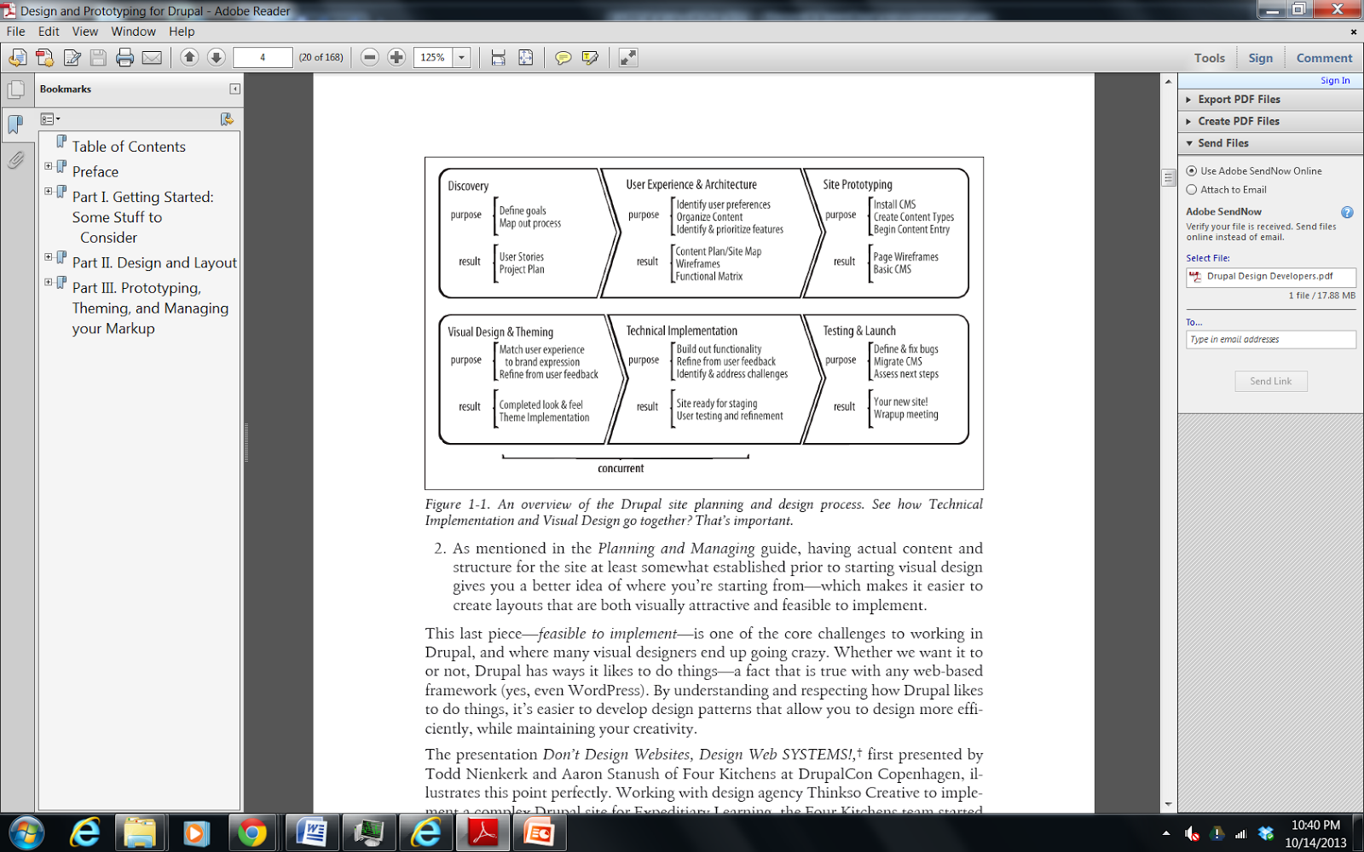

**Figure 1 - From Designing and Prototyping in Drupal, D. Nordin, 2012**

# 

# 3.0 UA Test Environment

Phase 1 PoC Application (cloud1)

* VMware view client
* Getting a Sandbox Account (username and password) <http://bitly.com/getsandboxcloudaccount>
* Create Your Own WebHelpDesk (WHD) Account
* [https://vacloud.us/groups/sandboxdocs/wiki/508a8/Getting_An_Innovation_Sandbox_Cloud_Account_a_login.html#step1](https://vacloud.us/groups/sandboxdocs/wiki/508a8/Getting_An_Innovation_Sandbox_Cloud_Account_a_login.html)

Phase 2 Initial UAT environment (cloud2)

Applicable IP addresses and URLs should be provided to the UAT Team and all workstations should be configured appropriately for access to the test environment.

Log on page: <http://184.73.210.16:8080/drupal/user/login>

Mantis Issue Tracking: http://www.room4me.com/raptortest1/bug_report_page.php

Phase 2 Final UAT Environment (data center)

Applicable IP addresses and URLs should be provided to the UAT Team and all workstations should be configured appropriately for access to the test environment.

## 3.1 UA Test Preparation

Test participants should provide the following as a pre-requisite for UAT:

**Table 2 - UAT Test Preparation**

|  |  |  |
| --- | --- | --- |
| **Date Requested** | **Outstanding SME Action Item** | **Status** |
| 10/15/13 | Site users, roles, and keywords. | Not complete.SAN has 2 of 4 sites.  Dr. Medverd has provided Seattle’s users, roles and keywords.Tuscon has also provided site info. |
| 10/24/13 | After reviewing existing protocols, provide additional protocol list and keywords for templates. | Not complete. SAN has 2 of 4 sites.  Seattle, Tuscon has provided protocol keywords. Fresno titles only. |
| 11/7/13 | Site’s Radlex mapping (conditional). | Not complete. SAN has 1 of 4 sites.  Dr. Medverd has provided Seattle’s mapping. |
| 11/19/13 | Review test data. | Not complete. |
| 12/5/13 | Provide site’s protocol pdfs on CD. | Not complete. SAN has 3 of 4 sites.  Fresno has provided CT, MR, NM pdfs. Tuscon has provided 2 CT pdfs. Dr. Medverd provided a few pdfs in the past. |
| 4/21/14 | Review list of contraindications. | SAN has initial POC list. |
| 4/29/14 | Provide dose details. Harmonize requirements with VA Enterprise guidance. | SAN has initial POC requirements. |
| 4/29/14 | Provide user’s collaboration keywords | Not complete. SAN has 2 of 4 sites.  Dr. Medverd has provided Seattle’s mapping. Tuscon has provided collaboration keywords. |
| 4/29/14 | Review the following efficiency reports:   * Time for each state * Total time from received to completed * Time from protocoled until scheduled * Time in collaboration * Number of tickets collaborated | Not complete |
| 4/29/14 | Review the following effectiveness reports:   * Frequency of collaboration by user * How many and what type of contraindications occur * Number of suspended tickets and breakdown by reason * Number of tickets changes by technologist | Not complete |
| 7/1/14 | Provide name and email for Mantis issue-tracking account. | Complete |
| 7/7/14 | Provide safety checklist examples. | Multiple sites provided. |

## 3.2 UA Test Data

The table above in 3.1 shows the user test data requested for UAT.

Access to test data is a vital component in conducting a comprehensive test of the system. All UAT participants will require usage of test accounts and other pertinent test data which should be provided by end user support upon request. Participants not currently utilizing test data must receive appropriate clearance and/or permissions to perform desired actions in the UAT environment. All user roles should fully emulate production in the UAT path. Completion of an online access request may be required in order to create test accounts.

# Roles and Responsibilities

Keys to a successful UAT process involve open channels of communication, detailed documentation, and above all, clearly defined roles and responsibilities. Each team member must function fluidly in a group setting as well as work independently for extended periods of time. UAT is largely a collaborative process and test results must be analyzed from different perspectives and by team members with various levels of expertise across the business to ensure success.

## 4.1 UAT Team

The test team is comprised of members who possess a thorough knowledge of the current systems and processing methods, i.e. SMEs. These team members will be better able to initiate test input, review the results, and be more intuitively familiar with the impact on other related business issues and staff activities. Members should be detail-oriented and be diligent in collecting proper documentation to support the test results. Team members are selected based, in part, on the ability of management to reassign the daily duties they will have to forgo while performing the testing.

All team members will be presented with an overview of the test process and what their specific role in UAT will be. SAN’s role in the UAT process is to oversee testing by assigning scripts to SMEs, providing general support, and serving as the primary UAT contact point throughout the test cycle. SAN will filter out any duplicate defects found and escalate high priority issues to the developers in a time sensitive manner.

**Table 3 - Roles and Responsibilities**

|  |  |  |  |  |  |
| --- | --- | --- | --- | --- | --- |
| **Name** | **Position** | **Primary Email** | **Alternate Email** | **Primary Phone** | **Alternate Phone** |
| **Seattle** |  |  |  |  |  |
| **Palo Alto** |  |  |  |  |  |
| **Portland, OR** |  |  |  |  |  |
| **Fresno** |  |  |  |  |  |
| **Tucson** |  |  |  |  |  |
| **VISN/Region Support** |  |  |  |  |  |
| **Contract Support** |  |  |  |  |  |
| **Program Office Support** |  |  |  |  |  |

# UAT Deliverables

The following sections detail milestones crucial to the completion of the UAT phase of the project. Once all dependent milestones have been completed, UAT will formally sign-off on the system’s functionality and distribute an e-mail to all project stakeholders.

## 5.1 UAT Activities

All core UAT activities are defined below:

* *Identify UAT Team* – Business Analyst lists SMEs that will take part in testing for the project. The Project Sponsor is often the source of information for the team list. A full description of team member attributes is detailed in section 4.1.
* *UAT Plan –* A strategy-based document defining test methodology and criteria is distributed to the team.
* *UAT Plan Team Review –* Session with business stakeholders to review plan and provide feedback.
* *UA Test Cases –* A document that details each specific test case that will be performed during the UAT process.
* *UA Test Procedures* – A detailed step-by-step breakdown of each individual test case.
* *UA Test Case Review* – Approval from business team and/or third parties on completed scripts.
* *UAT Environment Validation –* Validation of connectivity and expected results in the test environment for each end user participating in testing.
* *Test Case Execution –* Completion of all test scripts by test team.
* *Defect Tracking –* Defects will be entered and tracked via spreadsheet by the Business Analyst and/or Project Manager. Each entry will include detailed information about each defect.
* *UAT Touch Point –* Regularly scheduled meeting to evaluate UAT progress and outstanding defects.
* *UAT Sign-Off –* Formal sign-off indicating the system satisfies the needs of the business as specified in the functional requirements and provides confidence in its use.

## 5.2 UAT Schedule

Table of key deliverable dates and milestones below.

**Table 4 - UAT Schedule (June, July 2014)**

|  |  |  |  |
| --- | --- | --- | --- |
| **Item** | **Activity** | **Estimated Completion Date** | **Initials** |
| 1 | Identify UAT Team | 6/30/2014 |  |
| 2 | UAT Plan | 6/30/2014 |  |
| 3 | UAT Plan Team Review | 6/30/2014 |  |
| 4 | UA Test Case Walk Through | 7/7/2014 |  |
| 5 | Test Data Acquisition | 6/30/2014 |  |
| 6 | UA Test Scripts | 6/30/2014 |  |
| 7 | UA Test Script Approval | 6/30/2014 |  |
| 8 | Desktop Validation | 6/30/2014 |  |
| 9 | UAT Environment Validation | 6/30/2014 |  |
| 10 | Test Script Execution | Monday 7/7. Tuesday 7/8 |  |
| 11 | UAT Sign-Off |  |  |

# 6.0 UA Test Cases

Test cases provide a high-level description of the functionality to be tested. All regression and new functionality test cases are contained in the Excel spreadsheet “UA Test Cases” available at in SVN. The team plans to leverage relevant QA test cases for project specific functionality. Each test case based on new functionality will reference a specific functional requirement.

## 6.1 UA Test Cases

Test cases contain a detailed step by step breakdown of each test case to be performed by the UA tester. Each script contains: test case number, product, test description, requirement number, requester, tester, action to be performed, test data to be utilized, expected results, error descriptions (if applicable), pass/fail results, date tested, and any additional comments from the UA tester.

The UA test scripts are contained within the UAT test case spreadsheet and can be accessed via hyperlink from each individual test case.

# UAT Defects

Defects will be entered and tracked via the VHA Innovation Program web help desk <http://help.vacloud.us:8080/helpdesk/WebObjects/Helpdesk.woa/wo/79.9.1.1.1.0> by VA SMEs during the UAT process. Each entry will include detailed information about each defect.

## 7.1 UAT Defect Tracking

Team members will be provided with instruction on how to effectively execute test scripts, as well identify, capture, and report defects. Utilization of Microsoft Office applications and screen capture programs will be required to document defects for escalation. Team members will be expected to present findings on regularly scheduled touch point meetings in the event that end user support and/or Development require additional detail.

## 7.2 UAT Defect Prioritization

The Business Analyst will function as a liaison between the business and development on matters of prioritizing and classifying defects. Defects found in UAT can be assigned one of four (4) levels of severity:

* *Regulatory* – This request is regulatory and mandatory
* *Critical* – Testing defects that due to the complexity of the function or the scheduled dates are putting the implementation date at risk. No workaround exists.
* *High* – Testing defects occurring in a less complex function of the application with sufficient time to resolve before the implementation date – but must be implemented as scheduled. A workaround has been identified and is listed in the defect.
* *Low* – Testing defect occurring in a function that are simple to fix or could be excluded if not resolved by the scheduled implementation date.

## 7.3 UAT Defect Lifecycle

Defects must be clearly captured and escalated to ensure prompt resolution by development. Each defect submitted by UAT will be assigned a priority, worked by development, resolved, and re-tested by UAT prior to closure. The following is a snapshot of the standard defect lifecycle:

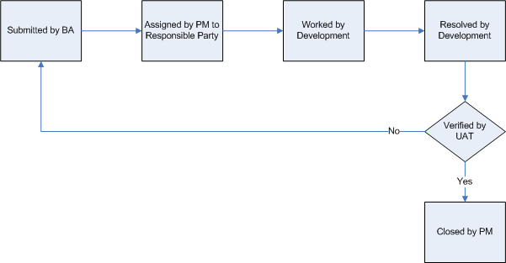

**Figure 2 - UAT Defect Lifecycle**

# Assumptions

The following are key assumptions made by UAT prior to the commencement of the acceptance test phase:

* QA testing has been completed without any outstanding critical defects.
* The UAT environment will be available for testing.
* Configuration information and test data has been provided and applied as designed.
* All desktops identified for UAT will have the necessary software applications installed.
* Subject Matter Experts (SME) are available to participate in testing.

**ISC Access/verify codes**

Access/verify codes have been edited for all of these users and accounts have

been re-enabled where appropriate:

The Innovation Sandbox Cloud (ISC) can be thought of as "VISN 0". Across all

VISN 0 VistA servers, there may be additional access & verify codes but the

codes listed below should be operable.

|  |
| --- |
| Each account has (3) menu options - OR CPRS GUI CHART, DVBA CAPRI GUI and MAG WINDOWS.  Each account has the MAGDISP CLIN security key. |

Login as VistA system administrator

Access code: 01vehu

Verify code: vehu01

Resident,Seattle (1radiologist/radiology1!)

Tworad,Demo (2radiologist/radiology2!)

Technologist,Seattle (3radiologist/radiology3!)

Scheduler,Seattle (4radiologist/radiology4!)

RADIOLOGIST,Portland (5radiologist/radiology5!)

RADIOLOGIST,Tucson (6radiologist/radiology6!)

RADIOLOGIST,Seattle (7radiologist/radiology7!)

Scheduler,Portland (8radiologist/radiology8!)

Scheduler,Tucson (9radiologist/radiology9!)

Scheduler,Fresno (10radiologist/radiology10!)

RADIOLOGIST,Fresno (11radioligst/radiology11!)

|  |
| --- |
| 12radiologist/radiology12!  13radiologist/radiology13!  14radiologist/radiology14!  15radiologist/radiology15!  16radiologist/radiology16!  17radiologist/radiology17!  18radiologist/radiology18!  19radiologist/radiology19!  20radiologist/radiology20!  21radiologist/radiology21!  22radiologist/radiology22!  23radiologist/radiology23!  24radiologist/radiology24!  25radiologist/radiology25!  26radiologist/radiology26!  27radiologist/radiology27!  28radiologist/radiology28!  29radiologist/radiology29!  30radiologist/radiology30!  31radiologist/radiology31!  32radiologist/radiology32!  33radiologist/radiology33!  34radiologist/radiology34!  35radiologist/radiology35!  36radiologist/radiology36!  37radiologist/radiology37!  38radiologist/radiology38!  39radiologist/radiology39!  40radiologist/radiology40! |

Within RAPTOR, user profiles were created for each role at each site.

The figure below shows the Mantis Tickets created from June 2014 to June 2015 when charting on the date submitted column. This shows that over the year of UAT testing that the trend is consistent throughout the year. This is illustrated by the number of horizontal lines that represent tickets entered over a particular date.

The only exception is December 2014, where few tickets were entered. This can be explained by users taking time off for the holidays and end of the year.

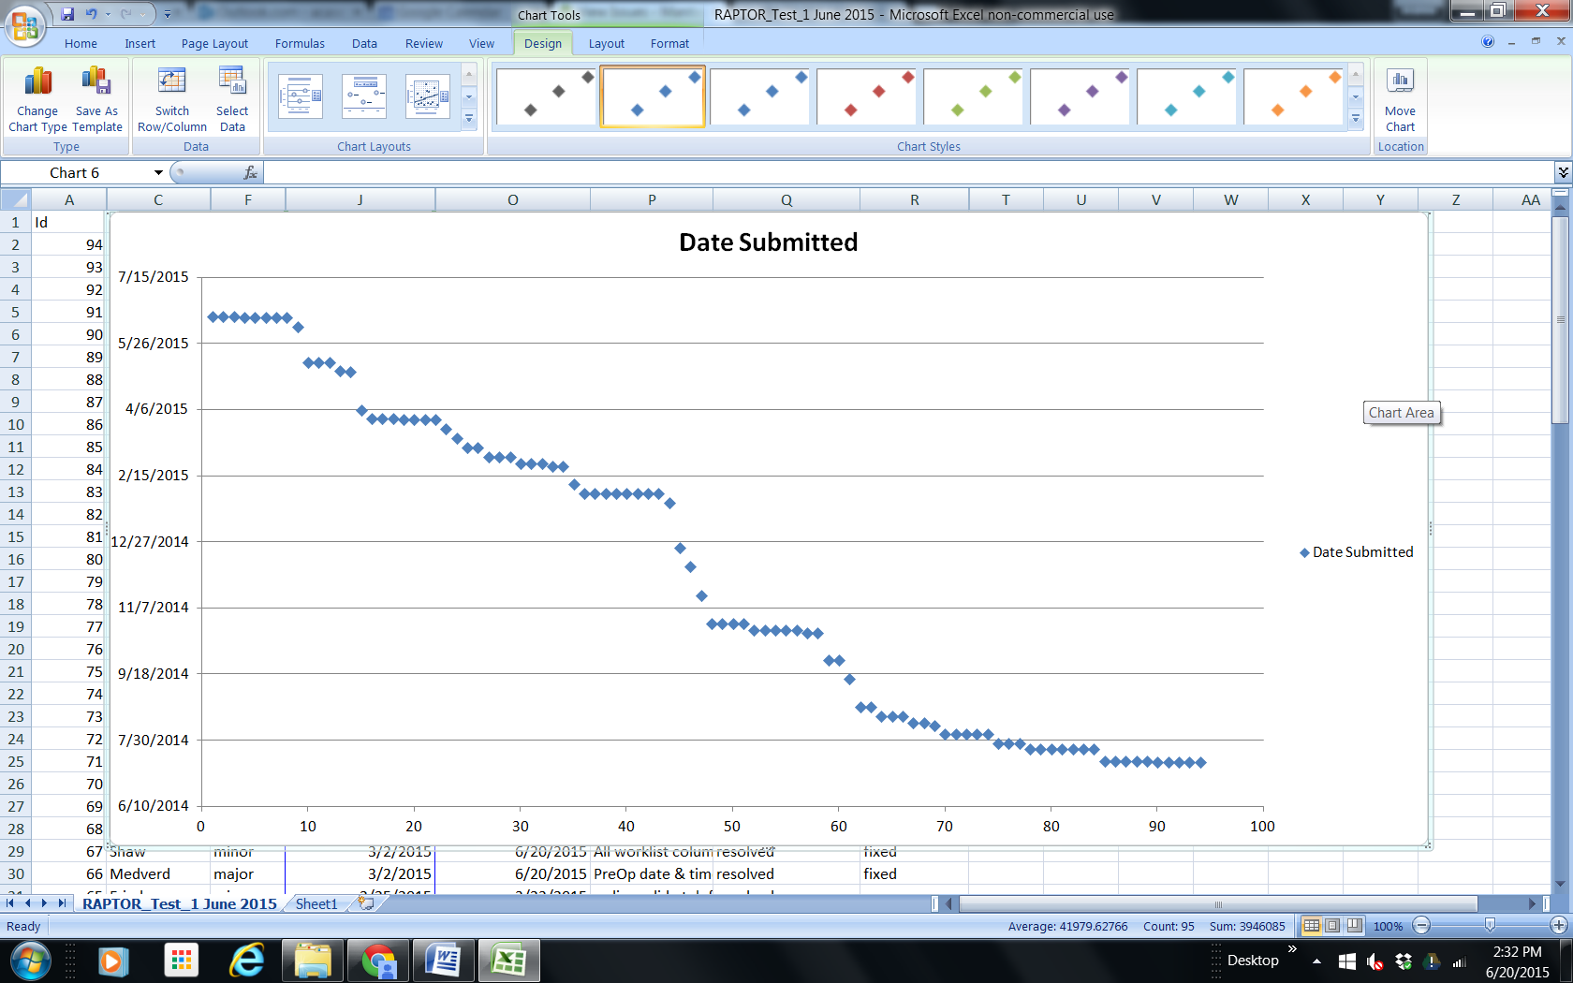

|  |  |  |  |
| --- | --- | --- | --- |
| Id | Date Submitted | Summary | Status |
| 94 | 6/16/2015 | Proposed Enhancement: noncontrast exams requiring acknowledgement of renal and allergy risk | new |
| 93 | 6/16/2015 | prioritization of exams | new |
| 92 | 6/16/2015 | Allergies list | new |
| 91 | 6/15/2015 | Block visibility of username input characters at RAPTOR login | resolved |
| 90 | 6/15/2015 | Rules refering to inpatient vs outpatient status are in list but cannot be built b/c no existing relevant flags | assigned |
| 89 | 6/15/2015 | Several rules and flags have transposition typo ("50" instead of "60") which scuttle functionality b/c point to nonsense | assigned |
| 88 | 6/15/2015 | Rule "diagnostic_exam_risk_med miscategorized and no existing flags from which to build functionality | assigned |
| 87 | 6/15/2015 | Upload protocol document should not be a required field | confirmed |
| 86 | 6/8/2015 | Error message, "Declared there are Contrast values but none were provided." | assigned |
| 85 | 5/12/2015 | Proposed Enhancement: Provide a mechanism for privileged users to create their own contraindications in RAPTOR | closed |
| 84 | 5/12/2015 | Proposed Enhancement: Allow contraindications to be configurable for acknowledgement | assigned |
| 83 | 5/12/2015 | Proposed Enhancement: Add Worklist filter mode - needs cancel replace action | assigned |
| 82 | 5/6/2015 | Proposed Enhancement: Update admin privilege label based on pass box name change | assigned |
| 81 | 5/5/2015 | Proposed Enhancement: Display Patient Name while scrolling down the screen | assigned |
| 80 | 4/6/2015 | Manage Contrast Options customization commands are not working | resolved |
| 79 | 3/31/2015 | Add visual cue(s) on worklist page to differentiate information from VistA vs RAPTOR-specific columns | closed |
| 78 | 3/31/2015 | Proposed Enhancement: Increase Commit Details to VistA Opportunities | resolved |
| 77 | 3/31/2015 | Machine produced radiation dose fluoroscopy | resolved |
| 76 | 3/30/2015 | QA Notes: Assessment Questions | assigned |
| 75 | 3/30/2015 | Proposed Enhancement: For FL, Change Minutes Radiation Dose Values to Total Flouroscopy Time | assigned |
| 74 | 3/30/2015 | Proposed Enhancement: Under the scheduling page, Remove the Add another Event | assigned |
| 73 | 3/30/2015 | Proposed Enhancement: Changes to the "Scheduling" functionality | assigned |
| 72 | 3/23/2015 | autopopulate Desired Date & Time from original order | assigned |
| 71 | 3/16/2015 | Substantial lag using Search Field in IE while displaying all entries | closed |
| 70 | 3/9/2015 | 'Replace Order' functionality tweeks needed | resolved |
| 69 | 3/9/2015 | Change Suspended label to Canceled | assigned |
| 68 | 3/2/2015 | Unable to save protocol | resolved |
| 67 | 3/2/2015 | All worklist columns appear to sort data alphabetically | resolved |
| 66 | 3/2/2015 | PreOp date & time must not be required fields within replace order routine | resolved |
| 65 | 2/25/2015 | radionuclide tab for MR | resolved |
| 64 | 2/25/2015 | contrast chooices should be modality relevant | resolved |
| 63 | 2/25/2015 | Cancel an exam privilege | resolved |
| 62 | 2/23/2015 | Clicking on cases where Workflow Status is Approved causes interminable wait | resolved |
| 61 | 2/23/2015 | UAT Worklist Functionality: Sort by Urgency still shows low ranked exam near top of list | resolved |
| 60 | 2/9/2015 | Unapprove button should reserve study to Radiologist who protocolled the study | closed |
| 59 | 2/2/2015 | Post protocol edit status message presentation | resolved |
| 58 | 2/2/2015 | 'Date Desired' & 'Date Ordered' sorting behavior unexpected | resolved |
| 57 | 2/2/2015 | Reopening #11 from this summer - Unable to see all worklist page columns | closed |
| 56 | 2/2/2015 | Scheduling functionality - cancel an exam & double book room | resolved |
| 55 | 2/2/2015 | Radiology reports tab default display needs to be reverse chronological | resolved |
| 54 | 2/2/2015 | Protocol page Contrast & Radionuclide protocol boxes tailored to modality type | resolved |
| 53 | 2/2/2015 | Enhancement: Specialization Display | resolved |
| 52 | 2/2/2015 | replace order functionality | resolved |
| 51 | 1/26/2015 | Proposed Enhancement: "append" original order with new order | assigned |
| 50 | 12/23/2014 | "Release back to worklist w/o saving" button returns user to 'QA' list sort mode | resolved |
| 49 | 12/9/2014 | Combine QA capabilities into Interpretation status | resolved |
| 48 | 11/17/2014 | Proposed Enhancement - Add additional labs for NM | assigned |
| 47 | 10/27/2014 | Proposed Behavior: Collapse Dose input screen | resolved |
| 46 | 10/27/2014 | Change radioisotope to radiopharmaceutical | assigned |
| 45 | 10/27/2014 | Change Status Message from Exam Completed to Examined | assigned |
| 44 | 10/27/2014 | Proposed Enhancement: Review Potiental Duplicates | closed |
| 43 | 10/22/2014 | Proposed Enhancement - Radiologist unable to recall or edit saved protocol | resolved |
| 42 | 10/22/2014 | Proposed Enhancement : the ability to reset the approved flag back to active | resolved |
| 41 | 10/22/2014 | Tech unable to set or change Procedure | resolved |
| 40 | 10/22/2014 | Is the "Notes Contain Patient Care Info Yes/No" option really necessary? | resolved |
| 39 | 10/22/2014 | Navigation issue | resolved |
| 38 | 10/20/2014 | Proposed Enhancement: use cases for identifying protocols | resolved |
| 37 | 10/20/2014 | add SSDE column in dose | closed |
| 36 | 9/29/2014 | Add modality to contraindication engine | resolved |
| 35 | 9/29/2014 | Proposed Enhancement: Add additional reporting | assigned |
| 34 | 9/15/2014 | Additional uncaught exception thrown while handling exception. | resolved |
| 33 | 8/25/2014 | Proposed Enhancement: In-Vivo/In-Vitro PYP RBC-Tagging Worksheet attached | assigned |
| 32 | 8/25/2014 | Proposed Enhancements: User Reports Extractions | assigned |
| 31 | 8/18/2014 | Exclude contrast list by relative modality | resolved |
| 30 | 8/18/2014 | Proposed Enhancement - Some contraindications could be dropped from being double checked | resolved |
| 29 | 8/18/2014 | Proposed Enhancement - Safety Checklist display behavior based on modality | resolved |
| 28 | 8/13/2014 | Screen Resolution issues in Protocol Page | closed |
| 27 | 8/13/2014 | Resident unable to fill in protocol options when study explicitly assigned. | closed |
| 26 | 8/11/2014 | IE issue: browser needs refresh - boxes display stacked. | assigned |
| 25 | 8/4/2014 | Proposed Enhancement: Tie into IMED Consent for Informed Consent | assigned |
| 24 | 8/4/2014 | Proposed Enhancement: Swap Protocol Pre-Medication Panel on Protocol Page: Contrast, Consent, Hydration, Sedation. | resolved |
| 23 | 8/4/2014 | Proposed Enhancement: filter scheduler notes to track needs cancel or replace | resolved |
| 22 | 8/4/2014 | Proposed Enhancement: CPRS Incident Report | assigned |
| 21 | 8/4/2014 | protocol update failed | resolved |
| 20 | 7/28/2014 | Proposed Enhancement: Add scroll boxes to scheduling page | resolved |
| 19 | 7/28/2014 | Proposed Enhancement: Validate Scheduling Room labels to correct modality. | assigned |
| 18 | 7/28/2014 | Proposed Enhancement: VistA Imaging notes and scans | assigned |
| 17 | 7/24/2014 | Unable to scroll left or right for wide columns | resolved |
| 16 | 7/24/2014 | Wrong Room | resolved |
| 15 | 7/24/2014 | Resident's selected protocols not appearing for Attending | resolved |
| 14 | 7/24/2014 | Unable to get a personal list | resolved |
| 13 | 7/24/2014 | Canceled Shows Scheduled | resolved |
| 12 | 7/24/2014 | 24hr time terribly unforgiving | resolved |
| 11 | 7/24/2014 | display: unable to see all columns | resolved |
| 10 | 7/15/2014 | Proposed Enhancement: Refresh Worklist Button to reset worklist to initial state of ranking from highest to lowest | resolved |
| 9 | 7/15/2014 | Proposed Enhancement: the REASON for Cancel | resolved |
| 8 | 7/15/2014 | Proposed Enhancement: For collaboration allow identification of expert criteria instead of a specific specialist name | assigned |
| 7 | 7/15/2014 | Proposed Enhancement: Additional code name field in Protocol Library | resolved |
| 6 | 7/15/2014 | Proposed Enhancement: Quick Keys for Exam Duration | resolved |
| 5 | 7/14/2014 | Proposed Enhancement: Color code scheduled columned status text | assigned |
| 4 | 7/14/2014 | Proposed Enhancement: Modality filter for Scheduler & technologist | assigned |
| 3 | 7/14/2014 | Proposed Enhancement: Adding Scheduling functionality | assigned |
| 2 | 7/14/2014 | IE9 used by VA Desktop, HTML5 viewer was developed in IE11 | resolved |
| 1 | 7/14/2014 | Chart Scales display incorrectly | resolved |